Anthonio dixon
Katowicka 87B, 45-061 Opole, Poland +48 577 418 761
anthonio.dixon@yahoo.com

Experience

NoveMBER 2018 – November 2020

eXECUTIVE CLIENT SUPPORT, Microsoft
- Drive continuous optimization of Microsoft partner’s performance as measured by revenue, pipeline, consumption, usage, and partner impact.

- Identify an effective to market with solutions and Go-to-Market activities.

- Help Microsoft Partners transform and grow their business in the cloud by developing comprehensive business plans identifying short- and long-term strategic goals.

March 2017 – March 2018

customer service rep, liberty global
- Billing Support
- Broadband Troubleshooting
- Customer Support

November 2016 – March 2017

customer service rep, CIGNA GLOBAL HEALTH INSURANCE
- Coverage Plan Selection
- Pre-Authorization
- Premiums and Billing

December 2015 – November 2016

RECORDS officer, mINISTRY OF JUSTICE
- Update personnel files for employees as requested
- Maintenance of Electronic Database
- Replace files to facilitate retrieval and access

Education

September 2020

BA International business, university of opole, poland

Skills

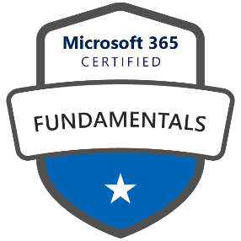
- Microsoft Certified Professional  - Business Analyst | - Web Developer  - Project Management  - Customer Service  - Marketing  - Pre-Sales Consultation  - SharePoint Developer

